How to Key Charge Off in SharePoint
Revision History
Date | Author | Comments
3/22/2019 | Singleton | Creation

Overview
This document will describe the process to create a Charge Off within SharePoint. A Charge Off is a financial loss due to an error working a dispute. This can be an error committed by a Worldpay rep, a vendor rep or due to a system error. Users requesting a Charge Off on behalf of our customers enter data into the Charge Off form. After all data is entered into the form, it can be reviewed via a SharePoint View.
Purpose
The purpose of this document is to provide a self-service guide for creating Charge Offs in SharePoint.
How to create a Charge Off
Go to the Charge Off section in SharePoint.
http://connected.infovantiv.com/BOPs/Lists/Disputes%20Charge%20Offs/Current%20Active.aspx
Follow these steps to create a Charge Off:
Step | Action | Responsible Role
1 | Before a Charge Off is keyed in the SharePoint site ensure that the request has not already been keyed. In order to check for duplicates change the drop down at the top of the screen of the Charge Off site to This List: Operations Charge Offs and then enter either the MID, ACRO or the case number in the search box and select search. If no results pull back proceed to Step 2. If a Charge Off is located ensure it is for the same issue, if it is the process stops here. See #Duplicates for a screen shot of how to search for duplicates. | Requestor
2 | If the Charge Off is related to a system issue open an incident ticket prior to filling out the Charge Off form. If the Charge Off is not related to a system issue proceed to Step 3. | Requestor
3 | Click on Add New Item located at bottom of screen. A screen will come up reading Operations Charge Offs – New Item See #NewItem for a screen shot of the location of the Add New Item button. Proceed to Step 4  NOTE: If a chargeoff has been reassigned to you by management correct any errors on the form, if needed, and resubmit.  If request is no longer valid update the Curent Queue to Cancelled. Update Current Request Status to Cancelled and add note as to why it is being closed. Enter Date Complete. | Requestor
4 | Fill in all pertinent information. All items with an asterisk (*) are required fields. See below link for detailed instructions on how to fill out the Charge Off form. \\connected.infovantiv.com\DavWWWRoot\BOPs\Documents\General Procedures\Ops Charge Off Initiation Instructions 022718 (2).doc  Note: if the Charge Off is due to a system error please ensure an incident ticket is opened and that the incident number is added to the Charge Off form. Proceed to Step 5 | Requestor
5 | If the Charge Off is due to a Vendor error the Charge Off needs to be assigned to the appropriate Vendor team lead or manager and then assigned to Pending Vendor Review queue.  Note: any system related issue should not be assigned to a Vendor for review  If the Charge Off is not due to a Vendor error the Charge Off needs to be assigned to the appropriate Worldpay manager and then assigned to the Pending Manager Approval queue.  Proceed to Step 6 | Requestor
6 | After all information is filled in select Save. | Requestor
7 | Receive notice that a Charge Off has been assigned to you. | Vendor team lead or WP manager
8 | Log in to SharePoint to review Charge Off by selecting the appropriate queue.  Vendor team Lead- Pending Vendor Review  WP manager- Pending Manager Approval | Vendor team lead or WP manager
10 | Review all information and either Approve or Reject the Charge Off. Prior to approval ensure that the form is filled out properly.  If approving proceed to Step 11  Vendor team Lead- if rejecting proceed to Step 12  WP Manager- If rejecting proceed to Step 15 | Vendor team lead or WP manager
11 | In order to Approve add in Note section of form that the Charge Off is approved.  Vendor Team Lead- Update Vendor Approval drop down to Approved by Vendor.  WP Manager- Type Name in Approved By Section  Once above is complete-  Vendor Team Lead- Proceed to Step 13  WP Manager- Proceed to Step 14 | Vendor team lead or WP manager
12 | In order to Reject the Charge Off add a Note in the Note section of form why you don’t approve the Charge Off and Update Vendor Approval drop down to Rejected by Vendor. Change Current Queue to Pending Manager Approval and assign to appropriate WP manager. (Flows back to step 7)  Note: the only reason a Charge Off should be rejected is because it is due to system issue AND an incident has already been opened.  END | Vendor team lead/manager
13 | Change Current Queue to Pending Manager Approval and assign to appropriate WP manager. END | Vendor team lead/ manager
14 | If Charge Off is financial (Financial Field=Yes) update the System Adj Field to identify where the Charge Off should be keyed. If Charge Off request is for an amount above $3,500.00 change Current Queue to Dept Head Review.  If Charge Off Request is for an amount below $3,500.00 change Current Queue to Key Adj. Update Current Request Status to Complete. Enter Date Complete.  If Charge Off is non financial (Financial Field=No) update Current Queue to Approved by Manager. Update Current Request Status to Complete. Enter Date Complete. END | WP Manager
15 | In order to Reject the Charge Off change Current Queue to Rejected by Manager. Update Current Request Status to Reject and add Note as to why the item was Rejected. Assign to original requestor. END | WP Manager
16 | Receive notice that Charge Off has been assigned to you. Proceed to Step 17 | Dept Head Approver
17 | Log in to SharePoint to review Charge Off by navigating to the Dept Head Review Queue. Proceed to Step 18 | Dept Head Approver
18 | Review all information and either Approve or Reject the Charge Off.  If approving proceed to Step 19  If rejecting proceed to Step 20 | Dept Head Approver
19 | In order to Approve add in Note section of form that the Charge Off is approved and select the appropriate dropdown in the Dept Head Approval field. Change Current Queue to Key Adj Queue. Update Current Request Status to Complete. Enter Date Complete. END | Dept Head Approver
20 | In order to Reject the Charge Off change Current Queue to Rejected By Manager and add notes as to why the item was Rejected. Update Current Request Status to Reject. Assign to Manager. END | Dept Head Approver
21 | If Charge Off was rejected the Requestor or Manager will Receive a notice that Charge Off has been assigned to them. Proceed to Step 22 | Requestor
22 | Log in to SharePoint to review Charge Off by navigating to the Rejected Items Queue. Proceed to Step 23 | Requestor
23 | Review the reject and determine if the Charge Off needs to be re-keyed. If it needs to be re-keyed refer to back to Step 2  If Charge Off does not need to be re-keyed close Charge Off by updating Curent Queue to Cancelled. Update Current Request Status to Cancelled updated Financial field to No and add note as to why it is being closed. Enter Date Complete. Process Ends. | Requestor
24 | Keying Clerk will Receive a notice that Charge Off has been assigned to them. Proceed to Step 25 | Keying Clerk
25 | Log in to SharePoint to review Charge Off. Select Key Adj queue to view all Charge Offs pending adjustment. Proceed to Step 26 | Keying Clerk
26 | Log into appropriate system identified on Charge Off form to key adj to merchant or FI. Once adjustment has been keyed proceed to Step 27 | Keying Clerk
27 | Udpate Current Queue to Charge Off Complete. Type your name as your signature in the Name of Adjuster field and type in the Date Adjustment Keyed. Process Ends | Keying Clerk

Search for Duplicates
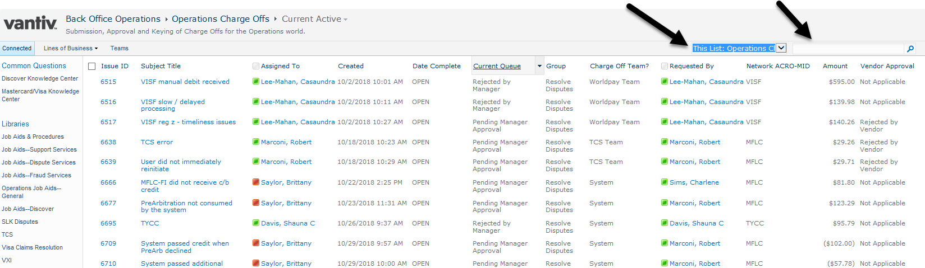

New Item
